New ways to work with Windows 7
Windows 7 simplifies how you work with the windows on your desktop. You'll have more intuitive ways to open, close, resize, and arrange them. You can drag open windows to screen borders, so you'll no longer have to click on tiny objects in the corner of a window to make it do what you want.
Maximize a window by dragging its border to the top of the screen, and return the window to its original size by dragging it away from the top of the screen. Drag the bottom border of a window to expand it vertically. It's easy to copy files or compare the contents of two windows by dragging the windows to opposite sides of the screen. As your cursor touches the edge, the window will resize to fill that half of the screen.
To see all your desktop gadgets, just drag your mouse to the lower right corner of your desktop. That'll make all the open Windows transparent—making your desktop, and the gadgets on it, immediately visible. Want to minimize all your windows? One click and it's done.
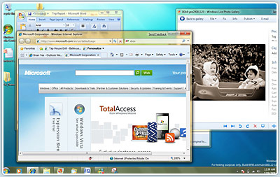
Now you see them
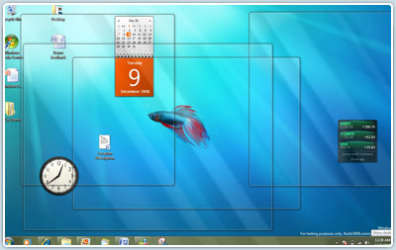
Now you don't: See through to the desktop with invisible windows

Improved taskbar and full-screen previews
The taskbar at the bottom of your screen is what you use to switch between the applications you've got open. In Windows 7 you can set the order in which the icons appear and they'll stay put. They're easier to see, too. Click once on the new large icons or bigger preview thumbnails and you're ready to go. You can even see a full screen preview before switching to the window.
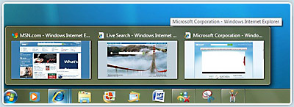

Jump Lists
With Windows 7, we focused on keeping the things you use most right in front of you. One example: The new Jump List feature. It's a handy way to quickly reach the files you've been working with. To see the files you've used recently, just right click on the icon on your taskbar. So right-clicking on the Word icon will show your most recent Word documents. Plus, if there are other files you want to keep handy, you can just pin them to the Jump List.
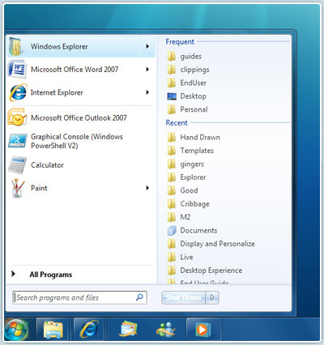
A leap in efficiency: Jump Lists provide quick access to common tasks

Windows Live
With Windows 7, some features previously included in the operating system are now available for download through Windows Live Essentials, a set of free applications available for your PC and supported by Windows 7. You can download Windows Live Messenger, Photo Gallery, Mail, Writer, Movie Maker, and more. With these great applications, you can improve your Windows experience, and benefit from faster delivery of these features and services.
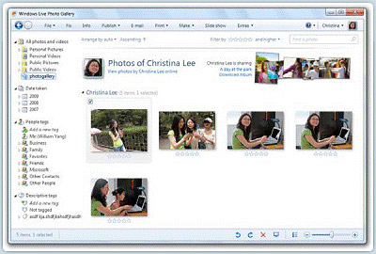

Better device management
One of the great things about PCs is how they let us use such a wide array of devices. In the past, you had to use several different screens to manage different types of devices. But With Windows 7, you'll use a single Devices and Printers screen to connect, manage, and use whatever printers, phones, and other devices you have on-hand.
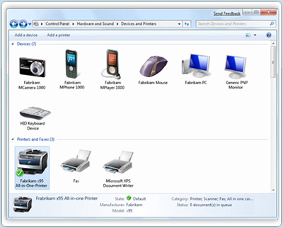
A new technology in Windows 7 called Device Stage takes device management a step further. Device Stage helps you interact with any compatible device connected to your computer. From Device Stage you can see device status and run common tasks from a single window.
There are even pictures of the devices which makes it really easy to see what's there.
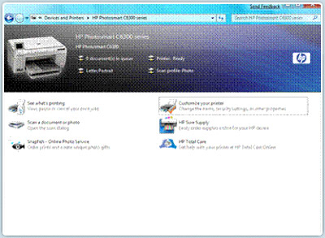

HomeGroup
Setting up a home network can be complicated. With PCs running Windows 7, a home network will be easier to setup and a lot more useful. HomeGroup makes it easier to connect to other computers and devices on a wireless home network, so you can share files, photos, music, and printers throughout your home. To use HomeGroup, you’ll need to have at least two PCs running Windows 7. Once you've set up a homegroup, you can use the Network and Sharing Center to choose what you share with other homegroup members.
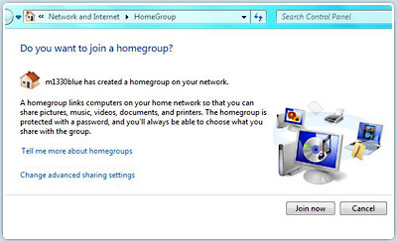
Decide whether to join an existing network
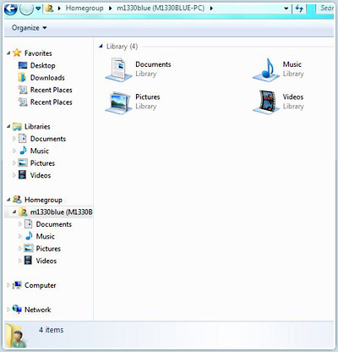
Easily explore content on other devices on the network
http://www.microsoft.com/windows/windows-7/whats-new.aspx

