Motorola 68000 microprocessor family
http://www.cpu-world.com/CPUs/68000/index.html
CPU » 68000
Previous Generation |  | Related Family | Next Generation
6800  - » 8-bit microprocessor  - » Up to 2 MHz  - » 64 KB RAM  - » No I/O ports  40-pin DIP | 68000  - » 32-bit CPU  - » 16-bit data bus  - » Up to 20 MHz  - » 16 MB RAM  - » No I/O ports  64-pin DIP  68-pin LCC  68-pin PGA | 68008  - » 8-bit data bus  - » Up to 16.67 MHz  - » 4 MB RAM | 68010  - » 32-bit CPU  - » 16-bit data bus  - » Up to 16 MHz  - » 16 MB RAM  - » Virtual memory support  - » No I/O ports  64-pin DIP  68-pin PLCC  68-pin PGA
Motorola 68000 (MC68000) is the first member of 680x0 line of microprocessors. Internally the 68000 is a 32-bit microprocessor - it has 32-bit data and address registers. Externally the processor has 16-bit data bus and 24-bit address bus, which limits the size of addressable memory to 16 MB. Motorola also made 68008 - a version of 68000 CPU with 8-bit external data bus. In addition to basic HMOS 68000 and 68008 processors the following modifications were produced:
- 68HC000 - low-power HCMOS version of Motorola 68000
- 68HC001 - low-power HCMOS version with selectable 8/16 bit external data bus.
- 68EC000 - embedded version
- 68SEC000 - embedded version of Motorola 68000 with static core
The 68000 architecture was much more flexible than other CPU families (z80, 80x86, z80000, etc) from programming point of view as it could be easily expanded to support full 32-bit data and address buses. This was done in Motorola 68020 family.
HMOS 68000 processors were manufactured at speeds up to 16 MHz. HCMOS 68000 microprocessors are still manufactured at this time (May 2007) at speeds up to 20 MHz.
Computers: | Apple Lisa 2, Apple Macintosh 128, Atari 520STfm and 1040STfm, Commodore Amiga 500 and 1000.
Die pictures: | Motorola MC68000L8

Apple
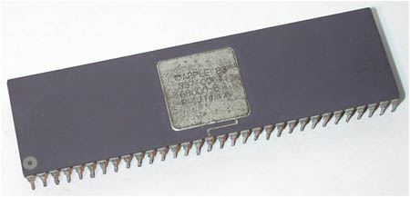
Apple 68000-8
8 MHz
64-pin side-brazed ceramic DIP
This 68000 microprocessor was not manufactured by Apple, but it was put into separate "Apple" category due to very unusual Apple copyright on the CPU. It's likely the CPU was manufactured by Hitachi as their 68000 processors have similar packaging and chip markings.

Hitachi
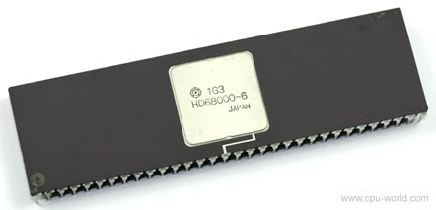
Hitachi HD68000-6
6 MHz
64-pin side-brazed ceramic DIP

Mostek
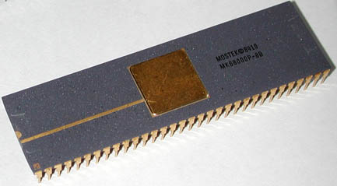
Mostek MK68000P-8B
8 MHz
64-pin plastic DIP

Motorola
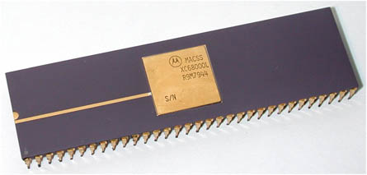
Motorola XC68000L (SN807)
64-pin side-brazed ceramic DIP
Very rare engineering sample of Motorola 68000 processor. First engineering samples of 68000 were marked with serial numbers. This specific chip was manufactured in October 1979 and has serial number 807.

Rockwell
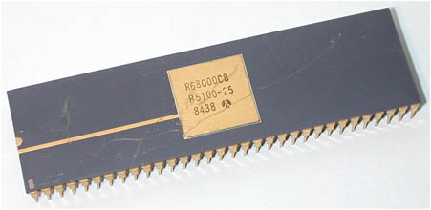
Rockwell R68000C8
8 MHz
64-pin side-brazed ceramic DIP

ST
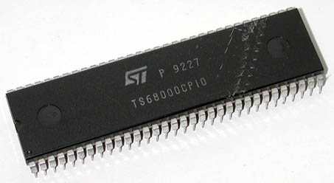
ST TS68000CP10
10 MHz
64-pin plastic DIP

Signetics
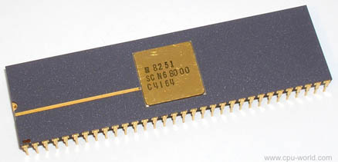
Signetics SCN68000C4I64
4 MHz
64-pin side-brazed ceramic DIP

Thomson
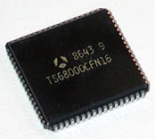
Thomson TS68000CFN16
16 MHz
68-lead plastic LCC

Toshiba
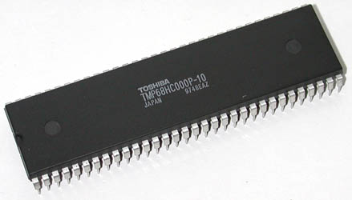
Toshiba TMP68HC000P-10
10 MHz
64-pin plastic DIP
Modifications

68000
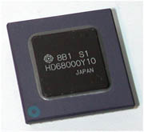
Hitachi HD68000Y10
10 MHz
68-pin ceramic PGA

68EC000
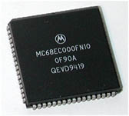
Motorola MC68EC000FN10
10 MHz
68-lead plastic LCC

68HC000
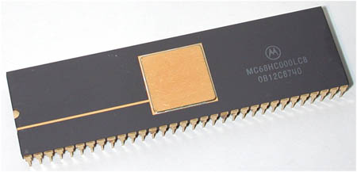
Motorola MC68HC000LC8
8 MHz
64-pin side-brazed ceramic DIP

68HC001
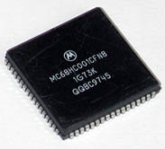
Motorola MC68HC001CFN8
8 MHz
68-lead plastic LCC
Extended temperature range -40 - +85°C

