Memory Types
http://home.pacbell.net/dbk4297/memory_what_kind.html

DDR3 240-pin DIMM Approximately 5.25” by 1.18”
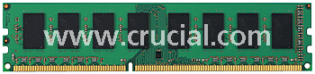
240-pin DIMM's are used in the newest and fastest DDR3 memory desktop computers. DDR3 is the latest generation of memory with an improved architecture that allows it to transmit data more quickly.
Each 240-pin DIMM provides a 64-bit data path (72-bit for ECC or registered or Fully Buffered modules). Standard DDR3 240-pin DIMMs are currently available in DDR3 PC3-8500 SDRAM and DDR3 PC3-12800 SDRAM. Additional speeds will be added as the technology becomes available.
To use DDR3 memory, your system motherboard must have 240-pin DIMM slots and a DDR3-enabled chipset.
A DDR3 SDRAM DIMM will not fit into a standard DDR2 DIMM socket or a DDR DIMM socket.
The number of black components on a 240-pin DIMM can vary, but it always has 120 pins on the front and 120 pins on the back, for a total of 240. 240-pin DIMMs are approximately 5.25 inches long and 1.18 inches high, though the heights can vary. While 240-pin DDR3 DIMMS, 240-pin DDR2 DIMMs, 184-pin DDR DIMMs, and 168-pin DIMMs are approximately the same size, 240-pin DIMMs and 184-pin DIMMs have only one notch within the row of pins.
DDR 2 240Pin - Used in newer Computers. 5.25” by 1.18”

240-pin DIMM's are used to provide DDR2 SDRAM memory for desktop computers.
Standard DDR2 240-pin DIMMs are available in DDR2 PC2-3200 SDRAM, DDR2 PC2-4200 SDRAM, DDR2 PC2-5300 SDRAM, PC2-6400 SDRAM and PC2-8000.
To use DDR2 memory, your system motherboard must have 240-pin DIMM slots and a DDR2-enabled chipset.
A DDR2 SDRAM DIMM will not fit into a standard SDRAM DIMM socket or a DDR3 DIMM socket. The number of black components on a 240-pin DIMM can vary, but it always has 120 pins on the front and 120 pins on the back, for a total of 240. 240-pin DIMMs are approximately 5.25 inches long and 1.18 inches high, though the heights can vary. While 240-pin DDR2 DIMMs, 184-pin DDR DIMMs, and 168-pin DIMMs are approximately the same size, 240-pin DIMMs and 184-pin DIMMs have only one notch within the row of pins. The notch in a 240-pin DDR2 DIMM is closer toward the center of the module.
Dual Channel mode memory. For systems that make use of dual channel memory mode, you must have two memory boards that are exactly the same or the dual channel portion will not work. Get two memory chips with the same part number if you want dual channel.
The dual-channel mode doubles the amount of available memory bandwidth. Dual-channel-enabled memory controllers utilize two 64-bit data channels, resulting in a total bandwidth of 128-bits, to move data from RAM to the CPU.

DDR 184 Pin - Used in newer desktop computers. 5.375” x 1”
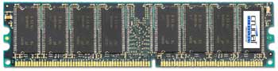
184-pin DIMMs are used to provide DDR SDRAM memory for desktop computers. Each 184-pin DIMM provides a 64-bit data path, so they are installed singly in 64-bit systems. 184-pin DIMMs are available in PC2100 DDR SDRAM, PC2700 DDR SDRAM, and PC3200 DDR SDRAM. To use DDR memory, your system motherboard must have 184-pin DIMM slots and a DDR-enabled chipset. A DDR SDRAM DIMM will not fit into a standard SDRAM DIMM socket. (Information on which memory technology is used by your system is included in the Memory Selector.)
The number of black components on a 184-pin DIMM may vary, but they always have 92 pins on the front and 92 pins on the back for a total of 184. 184-pin DIMMs are approximately 5.375" long and 1.25" high, though the heights may vary. While 184-pin DIMMs and 168-pin DIMMs are approximately the same size, 184-pin DIMMs have only one notch within the row of pins.
Dual Channel mode memory. For systems that make use of dual channel memory mode, you must have two memory boards that are exactly the same or the dual channel portion will not work. Get two memory chips with the same part number if you want dual channel.
SDRAM 168-pin - Used in older desktop computers. 5.375” x 1”
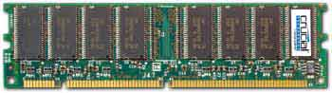
A dual inline memory module (DIMM) consists of a number of memory components (usually black) that are attached to a printed circuit board (usually green). The gold pins on the bottom of the DIMM provide a connection between the module and a socket on a larger printed circuit board. The pins on the front and back of a DIMM are not connected.
168-pin DIMMs are commonly found in Pentium® and Athlon® systems. 168-pin DIMMs are available in EDO, 66MHz SDRAM, PC100 SDRAM, and PC133 SDRAM. When upgrading, be sure to match the memory technology that is already in your system.
The number of black components on a 168-pin DIMM can vary, but it always has 84 pins on the front and 84 pins on the back, for a total of 168. 168-pin DIMMs are approximately 5.25 inches long and 1.375 inches high, though the heights can vary. They have two small notches within the row of pins along the bottom of the module.
Make sure that any memory that you buy is not only the correct type and pin count, but make certain that the speed you choose matches your memory BUSS speed.
Common speeds are SDRAM PC66, PC100, PC133. DDR PC-1600, PC-2100, PC-2400, PC-2700. DDR2 PC2-3200, PC2-4200, PC2-5300, PC2-6400, PC2-8000, PC2-8600. DDR3 PC3-6400, PC3-8500, PC3-10600, and PC3-12800.
For RDRAM, common speeds are PC600, PC700, PC800, and PC1066. The newest type of RDRAM are not listed as a PCnumber. Speeds are listed as RIMM1600, RIMM2100, RIMM3200, RIMM4200, RIMM6400, and RIMM8500. These new type or RDRAM chips will not fit in place old style RDRAM.

SODIMM 200-pin - DDR memory used in newer Laptop computers. 2.625” x 1.25”
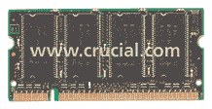
DDR2 SODIMM 200-pin - DDR memory used in newest Laptop computers. 2.625” x 1.18”
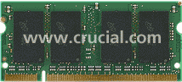
200-pin SODIMMs are used to provide DDR and DDR2 SDRAM memory for notebook computers. 200-pin SODIMMs are available in PC2700 DDR SDRAM, PC3200 DDR SDRAM, DDR2 PC2-6400 SDRAM, DDR2 PC2-5300 SDRAM, DDR2 PC2-4200 SDRAM and DDR2 PC2-3200 SDRAM. To use DDR or DDR2 memory, your system motherboard must have 200-pin SODIMM slots and a DDR- or DDR2-enabled chipset. A DDR or DDR2 SODIMM will not fit into a standard SDRAM SODIMM socket.
The number of black components on a 200-pin SODIMM can vary, but it always has 100 pins on the front and 100 pins on the back, for a total of 200. 200-pin SODIMMs are approximately 2.625” long and 1.25” high, though the heights can vary. Like 144-pin SODIMMs, 200-pin SODIMMs have one small notch within the row of pins; however, the notch on the 200-pin SODIMMs is closer to the left side of the module.

SODIMM 144-pin - Used in Laptop computers. 2.625” x 1”
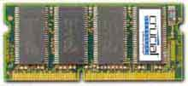
SODIMM 72-pin - Used on Laptop computers. 2.375” x 1”
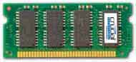
144-pin MICRODIMM - Used in sub-notebook computers. 1.545” x 1”
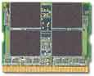
RDRAM PC1066 184-pin - Rambus memory for 533MHz memory buss. 5.25” x 1.25”
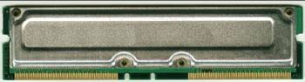
RDRAM PC RIMM 4200 232-pin 5.25” x 1.37”
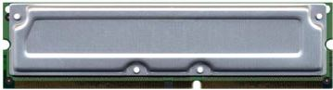
SIMM 72-pin - Used in very old desktops. 4.25” x 1”
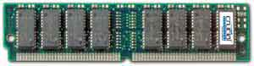
A single inline memory module (SIMM) consists of a number of memory components (usually black) that are attached to a printed circuit board (usually green). The gold or tin pins on the bottom of the SIMM provide a connection between the module and a socket on a larger printed circuit board. The pins on the front and back of a SIMM are connected.
72-pin SIMMs are commonly found in older desktop computers, such as the 486 and early Pentium® models. 72-pin SIMMs are available in FPM or EDO. When upgrading, be sure to match the memory technology that is already in your system.
SIMM 30-pin - Used in very very old desktops. 3.5” x .75”
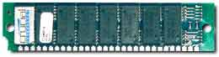
DIMM 100-pin - Used in some Printers. 3.5” x 1.25”
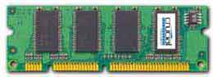
AIMM 66-pin - AGP inline memory module. 3.75” x 1.5”
