Intel Core i5 750 on Asus Maximus III Gene
http://www.theinquirer.net/inquirer/review/1533268/intel-core-i5-750-asus-maximus-iii-gene
First INQpressions Tales from Lynnfield
By Nebojsa Novakovic
Friday, 11 September 2009, 16:51
THE LYNNFIELD SERIES of Intel Core i7 and i5 processors promises to bring Intel's Nehalem architecture to the PC mainstream.
Fine, you've read about it pretty much everywhere these past few days, so there's no point in repeating the usual specs. However, within this LGA1156 mainstream socket family there are also high-end, mid-range and entry-level stratifications.
While Intel did separate the Core i5 and i7 CPUs in the new socket with the inclusion of HyperThreading - the vaunted simultaneous multithreading - for the i7 chips, as well as higher clock multipliers, there are no other differences save obviously price.
I do have to reiterate my reservations about the somewhat confusing naming scheme. To my mind, Intel should have reserved the Core i7 chips to the LGA1366 family, while assigning the Core i5 chips to the LGA1156 and placing the Core i3 chips, the dual-core and internal GPU parts, in those same LGA1156 sockets. That way, it would have been far clearer what the buyers are getting.
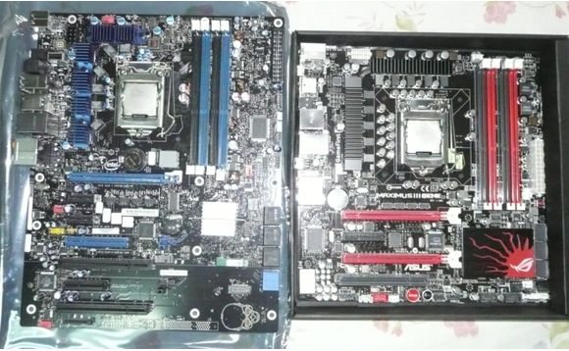
Here we look at both Core i7 870 processor and the Core i5 750 processor, one on the Intel DP55KG mainboard and the other on the Asus Maximus III Gene extreme motherboard. We'll also alternate between different memory module and cooling products for the newest CPU kids on the block. Each CPU gets its own five minutes of fame, taking the smaller one first.
So, the first part is combining the low-end CPU, the i5 750 - a bargain for quad-core processors at less than $200 a pop - with the high end mainboard. While it doesn't have hyperthreading, and it might not have all the OC capabilities of its more expensive brethren, it was a pleasure to insert it into a very capable little mainboard like the new Asus Maximus Extreme, where all the goodies fit on the quite compact MicroATX format. Take a look at the size comparison versus the larger Intel board. Nothing is missing feature-wise, so you could implement even a home theatre compact PC with decent overclocking capabilities.
Note the new socket on both boards. A somewhat funny fastening system is in place, where you have to fit the socket cover under a retention head, and tighten the side handle then under the cover. I find the one used for the LGA1366 socket far more user friendly. Nevertheless, it wasn't a problem fixing the new CPU in within a minute.
Since we save over $300 with this CPU, how far can we push it, within the layman's simple OC skills? I put aside my long experience with PC tuning, and tried to see what do we get - as a reliable, working setup, mind you - within just one BIOS test round, or about 2 minutes? So, I went for the Asus auto setting option to move up to 3.2 GHz by just upping the base clock to 160MHz instead of the usual 133MHz. As a result, the memory went up to DDR3-1600, which the two Kingston HyperX DIMMs handled without a hitch (yes, these are the surviving Elpida-based modules from the Japanese chip vendors' reliability fiasco earlier this year). Do note that, with one less memory channel, and it does seem to be a little easier to crank up the DDR3 frequency on the remaining two memory channels.
So, voila - the baby ran Windows Vista without any problems with the initial benchmarks I tried, all completing flawlessly. The big 4-heat pipe Thermalright heatsink with a 120 mm fan did help a bit, although Coolermaster and Thermaltake have even more advanced solutions for the new socket. I used the supplied ChillFactor thermal grease from Thermalright as well.
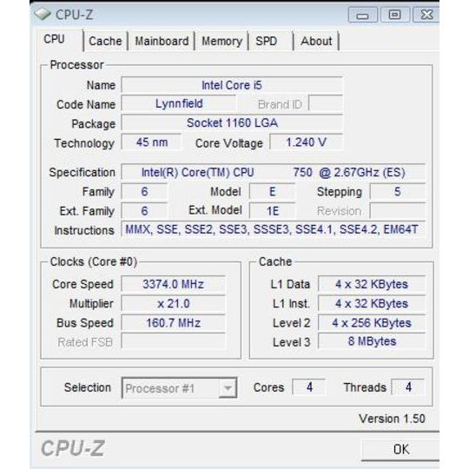
Using the very interesting combination of an Intel CPU with a top-end Asus board and a Gigabyte GTX275 OC graphics card, I ran the usual CPU-Z and Sandra benchmarks first. You can notice that CPU-Z correctly detected the Turbo mode working fine during the tests, and in fact the Turbo clock steps were correspondingly higher with the increased base clock. So, all four cores actually ran at one 160 MHz clock step higher than the existing 3.2 GHz frequency, reaching 3.37 GHz exactly. Not bad at all.
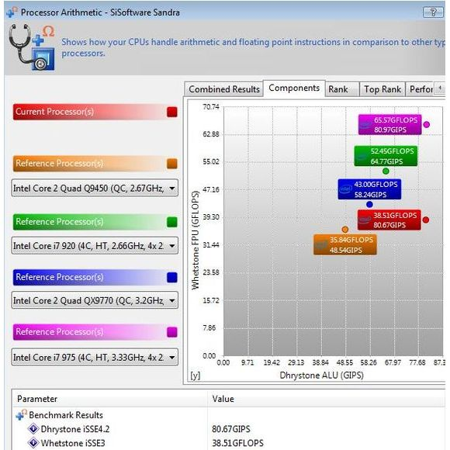
As you can see, on one of the CPU benchmarks - the integer one, the newbie actually matched the high end Core i7 975XE 3.33 GHz CPU. However, it was nearly half way down on the synthetic floating point test. I have only one explanation, this being a CPU without the hyperthreading option which does inflate the FP benchmarks. On the memory side, the i5 750 with dual channel DDR3-1600 matches the bigger i7 with triple-channel DDR3-1333 in default settings. Fair game, since I didn't push the memory latency settings beyond default on this boards yet either. It's also way ahead of the Phenom II on 790FX chipset.
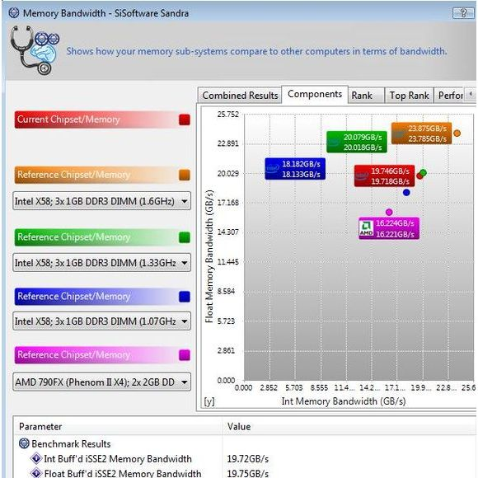
Now, let's remember again that this is an entry level CPU. It runs like a charm at 3.2 GHz without even including the Turbo yet, giving some pretty good performance even before we start kicking in some serious tuning. Those that did so already have these little babies running at about 4GHz. For a power-saving budget CPU with very decent balanced performance, the Core i5 750 does wonders. And yes, it is worth spending a bit of extra dosh on a good mainboard for it to get to those clocks safely.
In the second part, scheduled for Monday, we'll compare the little CPU with its bigger brother, the Core i7 870, on both boards, as well as with their even bigger brethren, the Core i7 LGA1366 socket CPUs. µ
Good:
Fantastic performance for entry level price.
Bad:
Its siblings are even faster.
Ugly:
The naming convention.
Beers: 9/10

